**Secção de Atletismo/Caminhada**

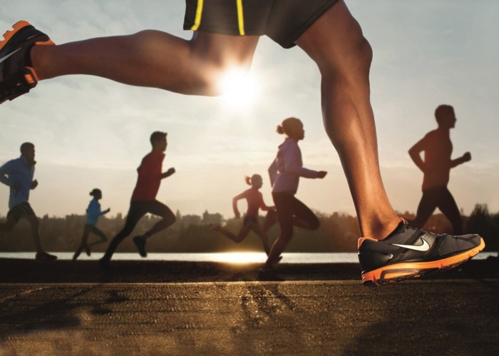

No âmbito da aproximação aos sócios o **GDC Fidelidade Núcleo Norte** vai criar a S**ecção de Atletismo/Caminhada**.

O seccionista que irá orientar esta modalidade é o colega **João Moreira**, colaborador da Fidelidade.

Os sócios interessados em participar deverão preencher a ficha de inscrição e enviar para o email

[cesar.augusto.ferreira@fidelidade.pt](mailto:cesar.augusto.ferreira@fidelidade.pt)

|  |  |  |  |  |  |  |  |  |  |  |  |  |  |  |  |  |  |  |  |  |  |  |  |  |  |  |  |  |  |  |  |  |  |  |  |  |  |  |  |  |  |  |  |  |  |  |  |  |  |  |  |  |  |  |  |  |  |  |  |  |  |  |  |  |  |  |  |  |  |  |  |  |  |  |  |  |  |  |  |  |  |  |  |  |  |  |  |  |  |  |  |  |  |  |  |  |  |  |  |  |  |  |  |  |  |  |  |  |  |  |  |  |  |  |  |  |  |  |  |  |  |  |  |  |  |  |  |  |  |  |
| --- | --- | --- | --- | --- | --- | --- | --- | --- | --- | --- | --- | --- | --- | --- | --- | --- | --- | --- | --- | --- | --- | --- | --- | --- | --- | --- | --- | --- | --- | --- | --- | --- | --- | --- | --- | --- | --- | --- | --- | --- | --- | --- | --- | --- | --- | --- | --- | --- | --- | --- | --- | --- | --- | --- | --- | --- | --- | --- | --- | --- | --- | --- | --- | --- | --- | --- | --- | --- | --- | --- | --- | --- | --- | --- | --- | --- | --- | --- | --- | --- | --- | --- | --- | --- | --- | --- | --- | --- | --- | --- | --- | --- | --- | --- | --- | --- | --- | --- | --- | --- | --- | --- | --- | --- | --- | --- | --- | --- | --- | --- | --- | --- | --- | --- | --- | --- | --- | --- | --- | --- | --- | --- | --- | --- | --- | --- | --- | --- | --- | --- |
| **Ficha de Inscrição** | | | | | | | | | | | | | | | | | | | | | | | | | | | | | | | | | | | | | | | | | | | | | | | | | | | | | | | | | | | | | | | | | | | | | | | | | | | | | | | | | | | | | | | | | | | | | | | | | | | | | | | | | | | | | | | | | | | | | | | | | | | | | | | | | | |
|  |  | |  | |  | |  | | | |  | | |  | | | |  | |  | | |  |  | |  | | |  | | |  | | |  | | |  | | |  | | |  |  | |  | |  |  | | |  | | |  | |  | | |  | | |  | | |  | | |  | |  | | |  | | |  | | |  | | | | |  | | | |  | | | | | | | | | | | | |  | | | | |  | | |  |  | | |  | | |  | |  | | | |  | |  | |  |  | |  | | | |  | | | |
| **Nome:** | | | | |  | | |  | | | | | | | | | | | | | | | | | | | | | | | | | | | | | | | | | | | | | | | | | | | | | | | | | | | | | | | | | | | | | | | | | | | | | | | | | |  | | | | | **Nº Sócio:** | | | | | | | | | | | | | | | | | |  | | | | | | | | | | | | | | | | | | | | |  | | | | | | | |  | | | | | | | | | | | | | | | | | | | | | |
|  |  | |  | |  | |  | | | |  | | |  | |  | | | |  | | |  |  | |  | | |  | | |  | | |  | | |  | | |  | | |  |  | |  | |  |  | | |  | | |  | |  | | |  | | |  | | |  | | |  | |  | | |  | | |  | | | |  | | | |  | | | |  | | | | | | | | | | | | |  | | |  | | | | |  |  | | |  | | |  | |  | | | |  | |  | |  |  | |  | | | |  | | | | | | | | | | | | | | | | | | | | |
| **Email:** | | | | | | | |  | | | | | | | | | | | | | | | | | | | | | | | | | | | | | | | | | | | | | | | | | | | | | | | | | | | | | | | | | | | | | | | | | | | | | | | | | | | |  | | | | | | | | | |  | | |  | | |  | | | | | | | | | | | | | | | | | | | | |
|  | | | | | |  | | | |  | | |  | | | |  | |  | | |  | |  | | |  | | |  | | |  |  | | |  | | |  | | |  | | | | | | | | |  | | |  | |  | | |  | | |  | | |  | |  | | |  | | |  | | |  | |  | | | |  | | | | |  | | | |  | | |  | |  | |  | | |  | | | | |  | | |  | | | | | |  | | | | | |  | | |  | |  | | |  | |  | | | |  | |  | | |  | |  |  |  | |  | | | | | | | | |
|  | |  | |  | | | | |  | | |  | | |  | | | | | |  | | | |  | | |  | | |  | | | | |  | | |  | | |  | | | |  | |  | | |  | | |  | | | | |  | | |  | | |  | | | |  | | | |  | | |  | | | |  | | | | |  | | | | | |  | | | | |  | |  | | |  | | |  | | | | |  | | | |  |  | | | | |  | | | |  | | | | | | | | | |  | | | |  | | |  | |  | | | |  | |  |  |  |  |  |  |  |  |
| **Assinatura:** | | | | | | | | |  | | | | | | | | | | | | | | | | | | | | | | | | | | | | | | | | | | | | | | | | | | | | | | | | | | | | | | | | | | | |  | | **Contacto:** | | | | | | | | | | | | | | | | | |  | | | |  | | | | | | | | | | | | | | | | | | | | **Data:** | | | |  | | | | | | | | | | | | | | | |